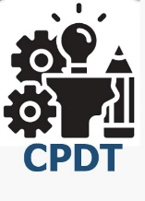
TITLE – “EDUCATION EQUITY”
A DESIGN PROJECT REPORT

Submitted by
V. JISHNU |  | 23071A12C9
K.HIMANADH |  | 23071A12A0
VAMSHI LAGISHETTY |  | 23071A05H0

VALLURUPALLI NAGESWARA RAO VIGNANA JYOTHI
INSTITUTE OF ENGINEERING AND TECHNOLOGY
An Autonomous, ISO 9001:2015 & QS I-Gauge Diamond Rated Institute, Accredited by NAAC with ‘A++’ Grade
NBA Accreditation for B.Tech. CE, EEE, ME, ECE, CSE, EIE, IT, AME, M. Tech. STRE, PE, AMS, SWE Programmes
Approved by AICTE, New Delhi, Affiliated to JNTUH, NIRF (2023) Rank band:101-150 in Engineering Category
College with Potential for Excellence by UGC, JNTUH-Recognized Research Centres: CE, EEE, ME, ECE, CSE Vignana Jyothi Nagar, Pragathi Nagar, Nizampet (S.O.), Hyderabad – 500 090, TS, India.
Telephone No: 040-2304 2758/59/60, Fax: 040-23042761
2024-2025

VALLURUPALLI NAGESWARA RAO VIGNANA JYOTHI
INSTITUTE OF ENGINEERING AND TECHNOLOGY
CENTRE FOR PRESENCING AND DESIGN THINKING
An Autonomous, ISO 9001:2015 & QS I-Gauge Diamond Rated Institute, Accredited by NAAC with ‘A++’ Grade
NBA Accreditation for B.Tech. CE, EEE, ME, ECE, CSE, EIE, IT, AME, M. Tech. STRE, PE, AMS, SWE Programmes
Approved by AICTE, New Delhi, Affiliated to JNTUH, NIRF (2023) Rank band:101-150 in Engineering Category
College with Potential for Excellence by UGC, JNTUH-Recognized Research Centres: CE, EEE, ME, ECE, CSE Vignana Jyothi Nagar, Pragathi Nagar, Nizampet (S.O.), Hyderabad – 500 090, TS, India.

CERTIFICATE
This is to certify that the project titled “<EDUCATION EQUITY>” is being submitted, by V.Jishnu (23071A12C9, IT), K.Himanadh (23071A12A0, IT), and Vamshi.L (23071A05H0 ), in partial fulfilment of the requirement for the award of degree of Bachelor of Technology to the Centre for Presencing and Design Thinking at the Vallurupalli Nageswara Rao Vignana Jyothi Institute of Engineering and Technology is a record of bona fide work carried out by them under our pedagogy. The results embodied in this Project have not been submitted to any other University or Institute for the award of any degree.
Project Mentor
Name & Designation:

Department:
VNRVJIET
Hyderabad
Internal Examiners External Examiners

ABSTRACT

Economic inequality remains a persistent challenge in urban areas, often exacerbated by unequal access to quality education. Low-income communities frequently lack access to essential educational resources such as skilled teachers, technological tools, and extracurricular opportunities. This disparity perpetuates a cycle of inequality, as individuals from these communities face significant barriers to pursuing higher education or acquiring the skills necessary for better-paying jobs.
The project, Education Equity, focuses on addressing this systemic issue by establishing community-based education centers. These centers will serve as accessible hubs offering free or low-cost tutoring, digital literacy programs, and vocational training tailored to the needs of low-income groups. By equipping individuals with critical skills and knowledge, these centers aim to improve their prospects for higher education and better employment opportunities, breaking the cycle of economic disparity.
The initiative involves the active participation of educators, volunteers, and local organizations to ensure the effective delivery of high-quality programs. By leveraging technology and community engagement, the project strives to create an inclusive and sustainable model for equitable education. The anticipated outcomes include enhanced educational attainment, increased employability, and a significant reduction in economic inequality among marginalized groups.
Ultimately, Education Equity aligns with the United Nations’ Sustainable Development Goal 10: Reduced Inequality, demonstrating how targeted interventions in education can foster social mobility and bridge the gap between socioeconomic groups.

Literature Survey
To support the development of a mentorship platform aimed at bridging the educational gap for underprivileged students, the following literature survey highlights the current research, strategies, and gaps in the domain:

1. Importance of Mentorship in Education
Mentorship has been identified as a key factor in enabling students, especially from marginalized backgrounds, to achieve academic and career success. Studies like Karcher, 2005 and Rhodes & DuBois, 2008 emphasize that mentorship improves academic outcomes, self-confidence, and long-term career planning. Effective mentorship programs, such as Big Brothers Big Sisters, have demonstrated success in increasing student engagement and reducing dropout rates.

2. Barriers to Education
Research by UNESCO Global Education Monitoring Report (2022) outlines barriers to education, including:
- Lack of access to skilled teachers in rural and low-income urban areas.
- Limited infrastructure and digital tools to support modern learning environments.
- Financial constraints that prevent access to quality education. These findings align with the survey insights gathered for this project, indicating the need for localized and technology-driven solutions.

3. Role of Digital Technology in Education
A growing body of literature highlights the potential of mobile and web technologies in overcoming access barriers. For instance, Deloitte’s Mobile Consumer Survey (2020) shows that mobile phones are the most accessible technology for students in underserved areas. Platforms such as Khan Academy and Coursera have successfully delivered learning content to millions of students globally, proving the scalability of digital solutions. However, studies also caution against challenges like digital literacy and inconsistent internet connectivity, which need to be addressed in platform design.

4. Vocational Training and Skill Building
Vocational education and extracurricular skill-building have been effective in preparing students for the workforce. A report by ILO (2021) on youth unemployment highlights the importance of early career guidance and skill-building activities tailored to local job markets. Initiatives such as Pratham’s skill-building programs in India have demonstrated success in training youth for employment in technology, healthcare, and trade sectors.

. Community Engagement Models
Programs like Teach For All and community-based initiatives in regions like Sub-Saharan Africa and Southeast Asia have shown the effectiveness of engaging local stakeholders to improve educational outcomes. Research indicates that combining community-driven efforts with institutional support leads to sustainable impacts. Involving local schools, NGOs, and corporate partners could amplify the effectiveness of mentorship platforms.

6. Data-Driven Education Solutions
The integration of data analytics into education systems is a growing trend. Studies such as Siemens & Long (2011) highlight how learning analytics can optimize educational outcomes by providing personalized content, tracking student performance, and identifying bottlenecks. Such technology-driven insights could enhance the proposed platform's ability to meet evolving needs effectively.

Identified Gaps and Future Research Areas
- Lack of localized content in vernacular languages for non-English-speaking communities.
- Limited research on the scalability of mentorship platforms in regions with inconsistent digital infrastructure.
- Insufficient focus on integrating vocational pathways with traditional education in platform-based models.
- Need for more data on the effectiveness of gamification in sustaining long-term student engagement.
This literature survey forms the foundation for the design of a scalable, student-focused mentorship platform aimed at addressing educational inequities in underserved communities.
TABLE OF CONTENTS
Details of Contents | Page no.
Abstract | iv
Literature Survey | v-vi
Table of Contents | vii
List of Tables | viii
List of Figures | ix
Chapter 1: Introduction to Problem | 1-3
1.1 Objective | 1
1.2 Outline | 2
1.3 Motivation | 3
1.4 Scope of the Project | 3
Chapter 2: Discover and define | 4-6
2.1 Empathy Interview | 4
2.2 User Needs | 5-6
Chapter 3: Point of View for your Problem Statement | 7-9
3.1 Define Point of View | 7
3.2 Pain points addressed | 8-9
Chapter 4: Ideation | 10-19
4.1 Ideation Tools Used | 10-15
4.2 Outcome of Ideation Phase | 15-19
Chapter 5: Prototype model | 20-21
5.1 latent Needs Addressed | 20
5.2 Evaluation of prototype Based on Desirability, Feasibility &  Viability | 20-21
5.3 Design for environment (Optional) | ---
Chapter 6: Mentor Interactions | 22-24
6.1 Mentor Suggestions | 22
6.2 Suggestions Incorporated in the project  Chapter 7: Conclusions and Future Scope | 23-24  25-26
7.1 Conclusions | 25
7.2 Future Scope | 26
References | 27
Appendix A: User Surveys | 28-31
A.1 Questionnaire for Users | 28-29
A.2 Text Transcripts of User Responses | 29-31

LIST OF TABLES
Details of Contents | Page #
Table 2.1: Key findings from survey | 5
Table 3.1: Key evaluation metrics | 5
Table 4.1: Brainstorming ideas and their feasibility | 12
Table 4.2 : Example of an Empathy Map for Poor Students | 14
Table 4.3: Prioritized Ideas Based on Feasibility and Impact | 17
Table 4.4: Key Features for Platform Prototype | 18
Table A.1: Appendix Table Caption 1 | 29

LIST OF FIGURES
Details of Contents | Page #
Figure 2.1: Impact of education inequity | 5
Figure 2.2: Community-based learning center model | 6
Figure 3.1: Stake holder collabaration model | 9
Figure 4.1: SCAMPER Technique Implementation Model | 15
Figure 4.2: Steps to tackle the issue | 16
Figure A.1: Primary Barriers of Education | 29
Figure A.2: Support Mechanism for Educational Access-1 | 30
Figure A.3: Support Mechanism for Educational Access-2 | 30

CHAPTER 1

INTRODUCTION
1.1Objective
The primary objective of this project is to create a comprehensive online portal that aims to encourage low-income students to pursue education beyond the 10th grade, addressing significant barriers such as the lack of awareness about career opportunities and the inequitable access to educational resources. Students from underprivileged backgrounds often lack the proper guidance and support when it comes to career choices and educational pathways, which can lead to early school dropout or limited career prospects. This project seeks to bridge that gap by offering equitable access to a range of resources, including career exploration tools, expert advice, scholarship opportunities, and detailed information about higher education programs. Through a user-friendly platform, the portal will empower students to make informed decisions about their futures, providing the guidance they need to navigate educational and career pathways with confidence.

In the long term, this initiative aspires to contribute to broader educational equity by equipping students from underserved communities with the knowledge, resources, and guidance they need to thrive academically and professionally. The project’s focus on education beyond the 10th grade will not only provide a foundation for academic success but will also help students explore career opportunities that they may not have previously considered, ultimately helping them secure better futures.

1.2 Introduction
Education plays a critical role in breaking the cycle of poverty and fostering social mobility, yet many students from low-income urban communities face significant barriers that hinder their ability to pursue higher education and career opportunities. Lack of awareness about career options, limited access to mentorship, and financial constraints often prevent these students from fully realizing their potential. This project seeks to address these issues by creating a comprehensive platform aimed at encouraging low-income students to pursue education beyond the 10th grade.
The initiative focuses on raising awareness about the importance of continuing education after high school and providing resources and guidance that will help these students navigate their academic and professional futures. Through structured awareness programs, career guidance workshops, and mentorship initiatives, the project will empower students to make informed decisions about their educational and career paths. The primary goal is to bridge the gap in access to higher education and career opportunities, providing students with the necessary tools and support to succeed.
Key components of the project include organizing workshops that cover topics like college applications, scholarships, and career exploration, as well as creating a mentorship program that connects students with professionals who can guide them. Additionally, a digital platform will be developed to provide students with access to educational resources, financial aid information, and career advice. By focusing on both academic guidance and financial literacy, the project aims to help students from urban low-income communities overcome the obstacles they face and achieve success in their educational and professional journeys.
Ultimately, this project seeks to create a more equitable educational environment by providing low-income students with the knowledge, resources, and mentorship they need to pursue higher education and career opportunities, helping to reduce poverty and inequality in urban communities.
1.3 Motivation
The necessity of this project is underscored by the growing disparity in educational access. According to recent studies, students from low-income families are less likely to receive career counseling or have access to information about higher education options, leading to missed opportunities. Approximately 45% of students from low-income households do not pursue higher education due to financial or informational barriers. By offering an online portal that consolidates educational resources, career advice, and mentorship, this project can directly impact these students' academic and professional lives. This initiative not only aims to improve educational outcomes but also helps address broader societal issues of inequality by empowering the next generation of talent from underserved communities.
1.4 Scope for the Work
The scope of this project is focused on creating a digital platform that:
- Provides personalized career path recommendations based on students’ strengths and interests.
- Offers access to expert advice from professionals and educators.
- Lists available scholarships and financial aid opportunities.
- Includes guides on navigating college applications and career decisions.
- Provides a community space for students to interact and share experiences.

CHAPTER 2

Discover and Define

Chapter 2: Discover and Define
2.1 Understanding the Problem
Economic inequality remains a persistent challenge in urban areas, often exacerbated by unequal access to quality education. Low-income communities frequently face barriers such as inadequate educational infrastructure, untrained educators, and limited access to technology. This disparity perpetuates cycles of poverty, restricting opportunities for social and economic mobility.
2.1.1 Factors Contributing to Educational Inequality
The following key factors contribute to the issue:
- Resource Scarcity: Schools in low-income neighborhoods often lack basic facilities, skilled teachers, and technological resources.
- Economic Constraints: Families with limited financial means cannot afford private tuition or extracurricular learning.
-Systemic Barriers: Socioeconomic biases in policy and school zoning disproportionately affect marginalized groups.
2.1.1.1 Impact on Communities
The unequal distribution of resources has significant implications, including:
-Lower Academic Performance: Students in underfunded schools often underperform compared to their peers in well-funded institutions
- Restricted Career Opportunities: Without adequate education, individuals face challenges in securing stable, well-paying jobs.
-Intergenerational Poverty: Lack of education perpetuates economic disparity across generations.
2.2 Defining the Solution
The Education Equity project seeks to address these challenges through community-based education centers. These centers will provide free or low-cost services, including tutoring, digital literacy, and vocational training, specifically designed to meet the needs of low-income populations.
Key Insights from Surveys
Surveys conducted among urban low-income families revealed the following:
- 65% of respondents identified a lack of affordable educational resources as a major barrier.
- 78% expressed interest in vocational training programs to improve employability.
- 82% preferred community-based learning centers over distant institutions.
Table 2.1: Key Findings from Surveys
Factor | Percentage of Respondents
Lack of affordable resources | 65%
Interest in vocational training | 78%
Preference for local centers | 82%

Figure 2.1: Impact of Education Inequity
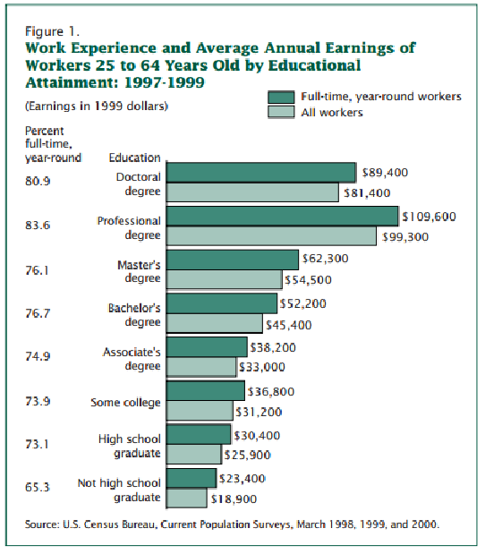
2.2.1 Goals of Education Equity
The primary objectives of the initiative include:
- Establishing easily accessible education hubs in underserved areas.
- Collaborating with educators, volunteers, and local organizations to deliver high-quality programs.
- Leveraging technology to enhance learning experiences and bridge resource gaps.
2.2.1.1 Anticipated Outcomes
The initiative aims to achieve the following outcomes:
- Increased educational attainment among marginalized groups.
- Improved employability due to vocational and digital literacy training.
- Reduction in economic inequality, fostering greater social mobility.
Figure 2.2: Community-Based Learning Center Model
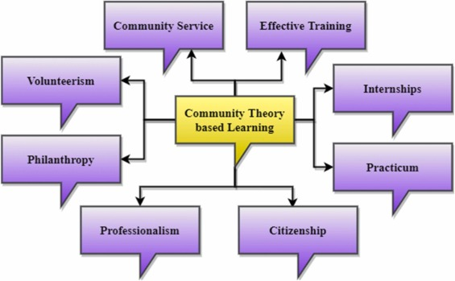

CHAPTER 3
Point of View of our Problem Statement
3.1 Framing the Perspective
Addressing educational inequality requires a shift in perspective from simply providing resources to actively involving communities in shaping the solutions. By understanding the lived experiences of marginalized groups, it becomes possible to develop interventions that truly resonate with their needs and aspirations. This approach moves beyond surface-level fixes to address the root causes of inequity and ensure meaningful, lasting impact.

The core perspective driving this project is rooted in empathy and inclusivity. It recognizes that solutions must be co-created with the communities they aim to serve, leveraging local knowledge, strengths, and values. Education Equity, therefore, positions itself as a catalyst for empowerment, enabling communities to break free from cycles of poverty and marginalization.
3.1.1 Recognizing Core Challenges
The Education Equity initiative acknowledges the interconnected challenges faced by low-income communities:

Many educational resources remain out of reach due to geographic and financial barriers. This often results in families being unable to access basic educational materials or participate in supplementary learning programs. Additionally, a lack of trust in external institutions, often stemming from past experiences of neglect or failure, discourages participation in new initiatives. Sustainability is another key challenge; programs that rely solely on external funding or short-term interventions often fail to create lasting change.

Community engagement revealed critical insights, such as parents expressing the need for flexible learning schedules that accommodate work commitments. Students showed a preference for hands-on, experiential learning methods, which align more closely with their aspirations and practical needs. Local organizations emphasized the value of culturally relevant curricula and the importance of addressing systemic inequities.
3.1.1.1 Insights from the Community
The voices of community members are central to shaping the project. Parents highlighted the difficulty of balancing work with their children’s education, necessitating flexible, after-hours tutoring sessions. Students, especially adolescents, expressed a desire for vocational training that equips them with job-ready skills, such as computer literacy or trades-based expertise. Local leaders underscored the importance of integrating cultural elements into educational content, making it more relatable and impactful for students.
3.2 Collaborative Solutions
Collaborative solutions are key to addressing educational inequality. By bringing together stakeholders such as educators, policymakers, community leaders, and local organizations, the Education Equity project aims to create a holistic and sustainable framework for change. These collaborations foster trust, build capacity, and ensure the inclusion of diverse perspectives in program design and delivery.

The project will prioritize transparent and inclusive decision-making processes. For instance, community representatives will be actively involved in selecting curricula and scheduling programs to ensure alignment with local needs. By adopting a participatory approach, the project aims to strengthen trust and ownership among beneficiaries, laying the groundwork for long-term success.

Developing scalable and flexible educational models is another focus. The centers will feature modular program designs, allowing customization based on local demographics and resource availability. Technology integration will play a vital role, enabling remote learning options and expanding the reach of educational services.
Evaluating Success
Success will be evaluated through comprehensive metrics such as enrollment rates, skill acquisition levels, and economic impact. Tracking enrollment rates provides insights into program accessibility and appeal. Measuring skill acquisition helps assess the effectiveness of training modules, particularly in areas like digital literacy and vocational skills. Monitoring economic impact through surveys and employment data will reveal the broader benefits of the initiative, such as increased income levels and improved job security among participants.
Table 3.1: Key Evaluation Metrics
Metric | Measurement Approach
Enrollment Rates | Participant registration records
Skill Acquisition | Pre- and post-training assessments
Economic Impact | Surveys and employment data

Figure 3.1: Stakeholder Collaboration Model
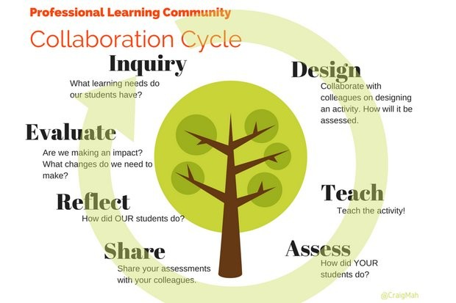

3.2.1 Long-Term Vision
The Education Equity project envisions a future where educational opportunities are no longer determined by socioeconomic status. By dismantling systemic barriers and empowering marginalized groups, the initiative seeks to foster a society where everyone has the tools to achieve their potential. This vision aligns with the broader goals of social justice and sustainable development, reinforcing the transformative power of education as a catalyst for change.

This chapter elaborates on the perspective guiding the Education Equity initiative. By focusing on collaboration, empathy, and measurable outcomes, the project aims to address the root causes of educational inequality and create meaningful, lasting impact in underserved communities.

CHAPTER 4

Ideation

4.1 Ideation Tools Used
Ideation involves brainstorming, problem-solving, and generating innovative solutions to the challenges that students from disadvantaged backgrounds face. This stage allows for the development of ideas that can later be prototyped and tested. Below, we explore several ideation methods that can be effectively utilized for this project, with a focus on creating an online platform to guide students from these communities in their educational journey.

4.1.1. Brainstorming Sessions
Brainstorming is one of the most popular ideation techniques and plays a pivotal role in generating a wide variety of ideas quickly. For this project, brainstorming sessions can be conducted with different stakeholders, including students, teachers, community leaders, and experts in education.


Process
- Problem Definition: Clearly define the problem for the brainstorming session. In this case, the problem is how to provide better access to information and guidance regarding post-10th education opportunities for students in rural and urban poor areas.
- Diverse Participants: Bring together people from different backgrounds—rural students, urban poor students, educators, social workers, and even local government representatives. This diversity will lead to a wider range of ideas.
- Idea Generation: Encourage participants to share any and all ideas without judgment. Quantity is important in this phase, and the goal is to gather as many solutions as possible.
- Idea Evaluation: After generating ideas, prioritize them based on feasibility, impact, and relevance to the users.

Example Ideas from Brainstorming
- A mobile-friendly website or app that provides free counseling services from educators and industry experts.
- A community-driven forum where students from similar backgrounds can share experiences, resources, and opportunities.
- Virtual mentorship programs connecting students with professionals in fields like engineering, healthcare, arts, and technology.
Table 4.1: Brainstorming Ideas and their Feasibility
Brainstorming ideas for a website aimed at mentoring poor students after 10th grade, with a focus on education equity, involves developing solutions that are accessible, relevant, and sustainable.
Ideas like personalized learning pathways, mentor-mentee matching systems, free online resources, and virtual internships can empower students by providing tailored academic and career guidance.
Feasibility hinges on factors such as accessibility, resource availability, and partnerships with educators, mentors, and organizations. Ensuring that the platform is user-friendly, low-cost, and adaptable to varying digital literacy levels is crucial for its success.
The integration of community support, real-world exposure, and skill development opportunities further enhances the platform's potential to make a meaningful impact.
Expanding on the feasibility of these ideas, it is essential to recognize the logistical and technical considerations that will influence the platform's success. For instance, a robust and intuitive user interface must be designed to accommodate varying levels of digital literacy, especially for students from underprivileged backgrounds.
Additionally, ensuring the platform is mobile-friendly is crucial, as many students may have limited access to computers but may own smartphones.
The platform must also offer multilingual support to cater to students from diverse linguistic backgrounds. Collaborating with local educational institutions, non-profit organizations, and corporate sponsors could help secure funding and mentorship opportunities, as well as provide access to internships and scholarships.
Finally, continuous monitoring and feedback mechanisms will be needed to evaluate the effectiveness of the mentorship and resources provided, allowing for adjustments and improvements over time to ensure that the platform remains responsive to students' evolving needs.
Personalized Learning Pathways
- Idea: Develop a system that helps students create personalized academic or career paths based on their interests, strengths, and resources available.
- Feasibility: This can be implemented by using a questionnaire or AI-based tool that evaluates the student's preferences, skills, and potential career options. Collaboration with academic advisors or professionals from various industries may be necessary to ensure guidance is relevant.
Table4.1 Brainstorming-Ideas

SNO. | Idea Description | Feasibility | Impact | Ease of Execution
1 | Mobile app for career counseling and advice | High | High | Moderate
2 | Virtual mentorship programs with professionals and alumni | Moderate | High | High
3 | Community-driven forum for peer support and idea sharing | High | Moderate | High
4 | Interactive videos on post-10th educational options, scholarships, and exams | High | High | High

4.1.2 Role Play and Empathy Mapping
Example Role Play Scenario:
- The mentor and student interact via a messaging platform or video call. The mentor tries to understand the student’s strengths, interests, and goals. The student, unsure about their future and unable to access high-quality career counseling, is hesitant to open up at first.

Role play and empathy mapping are techniques that help designers and stakeholders understand the lived experiences of the end users. By stepping into the shoes of rural and urban poor students, the team can better identify their needs, fears, and aspirations.

Process
- Role Play: Have team members role-play as students from rural and urban poor backgrounds, navigating their educational decisions after 10th grade. This can be done in a classroom or virtual environment.
- Empathy Mapping: Create an empathy map for these students. The map helps the team understand:
  - What students say about their educational journey.
  - What they think about their prospects and options.
  - What they do in terms of their daily routines and efforts to explore educational opportunities.
  - What they feel about their challenges, such as lack of access to information, financial constraints, or family responsibilities.

Mind Mapping

Mind mapping is an effective ideation technique that helps organize thoughts, visualize relationships between ideas, and explore different facets of a problem. It allows the team to build on each other’s ideas and create a holistic understanding of the challenge.

Process

- Central Idea: Start with the central concept—here, it is "education equity for rural and urban poor students."
- Branches: Create branches for different categories related to this idea, such as “Information Access,” “Mentorship,” “Technological Solutions,” and “Community Involvement.”
- Sub-Branches: For each branch, develop sub-branches with specific solutions. For example, under “Technological Solutions,” sub-branches might include mobile apps, websites, SMS-based updates, or voice-based technology for low-literacy users.
- Iteration: Expand and refine the mind map over time, adding new insights as they arise.

Table 4.2: Example of an Empathy Map for Rural and Urban Poor Students
What they say | What they think | What they do | What they feel
“I don’t know what courses to take after 10th.” | “I don’t think I can afford higher education.” | Study for exams with limited resources. | Overwhelmed, uncertain, stressed about the future.
“There’s no one to guide me about careers.” | “I want to do something good for my family.” | Seek help from teachers or peers. | Hopeful, but discouraged by lack of opportunities.
“I wish there was someone who could guide me.” | “I fear not being able to achieve my dreams.” | Watch videos on YouTube or WhatsApp for guidance. | Fearful, motivated to succeed despite challenges.

4.1.3 SCAMPER Technique
SCAMPER is a creative thinking technique that involves modifying an existing product, service, or system to generate new ideas. The acronym stands for Substitute, Combine, Adapt, Modify, Put to another use, Eliminate, and Reverse.

Process
- Substitute: What can be substituted to make the platform more user-friendly for rural or urban poor students? (e.g., replacing text-heavy content with video or voice-based content for low-literacy users).
- Combine: What existing services or ideas can be combined to improve the platform? (e.g., combining career counseling with scholarship information).
- Adapt: How can the platform be adapted to different contexts or needs? (e.g., making the platform available in regional languages or offline mode for low connectivity areas).
- Modify: How can the user interface be modified to be more accessible and attractive to students?
- Put to Another Use: How can the platform’s features be used to serve other purposes, such as providing job placement services after education?
- Eliminate: What unnecessary features or barriers can be eliminated to improve the user experience?
- Reverse: How might the user experience be flipped to provide more value? (e.g., turning the mentorship model into a reverse mentorship system where students teach others).
Figure 4.1: SCAMPER Technique Implementation Model

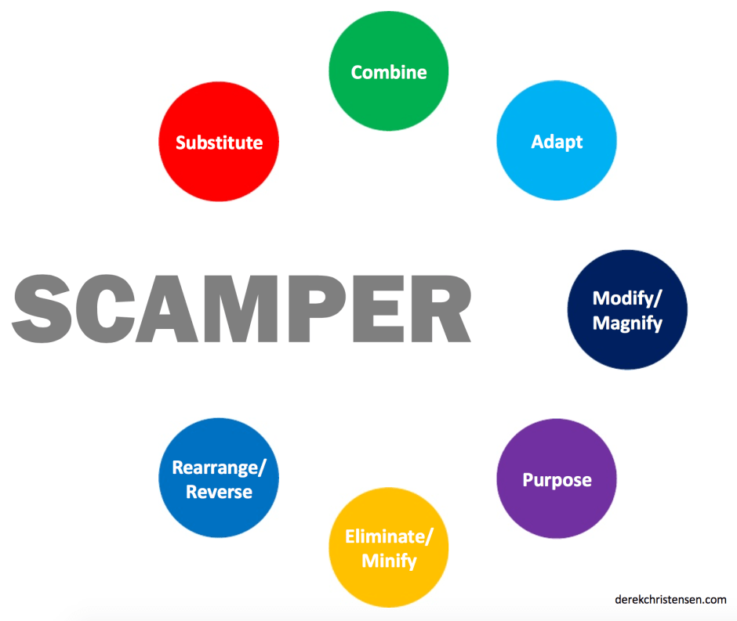

4.2 Outcome of Ideation Phase
The ideation phase is crucial in the design thinking process, as it transforms abstract problems into concrete solutions. For the education equity project aimed at assisting rural and urban poor students in India to explore educational opportunities after their 10th grade, the outcome of the ideation phase provides a roadmap for addressing the key challenges these students face. The outcome includes a clear set of ideas and concepts that have the potential to guide the development of the platform. These ideas are based on the ideation methods described earlier, such as brainstorming, mind mapping, empathy mapping, "How Might We" questions, and the SCAMPER technique.

4.2.1 Identifying Core Problems and Solutions
Through the ideation methods, several core challenges faced by students from rural and urban poor backgrounds were identified. The main problems are the lack of access to information, guidance, and mentorship regarding post-10th education options. The solutions proposed during the ideation phase address these issues in various ways, providing both technological and social interventions. The following outcomes reflect how these challenges were tackled.

Core Problems Identified
- Limited Access to Information: Many students do not have easy access to information about scholarships, courses, and career opportunities.
- Lack of Guidance and Mentorship: Students from disadvantaged backgrounds often lack mentors to guide them in making educational and career decisions.
- Technological Barriers: Limited internet access, especially in rural areas, makes it difficult for students to explore educational resources online.
- Financial Constraints: Many students face financial challenges that prevent them from pursuing higher education, making it difficult for them to access opportunities that would help them improve their situation.
Figure 4.2: Steps to tackle the issue:
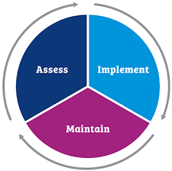

Solutions Proposed
- Mobile-Friendly Platform: To address the issue of limited access to information, a mobile-friendly platform was proposed. This platform would offer free access to information about scholarships, courses, exams, and career guidance.
- Mentorship Programs: Virtual mentorship programs connecting students with professionals and industry experts were identified as a way to provide the much-needed guidance and career advice.
- Offline Accessibility: To tackle technological barriers, the platform could include offline modes where students can download resources and access them without an internet connection.
- Financial Aid Database: A database of scholarships and financial aid options would help students from poor backgrounds access opportunities to fund their education.

4.2.2 Prioritization of Ideas
After brainstorming and using the SCAMPER method, a number of ideas emerged. The following table ranks the proposed ideas based on feasibility, impact, and alignment with the project's objectives.
Table 4.3:Prioritized Ideas Based on Feasibility and Impact
SNO | Idea Description | Feasibility | Impact | Execution | Priority
1 | Mobile-friendly platform providing career guidance, scholarships, and courses. | High | High | High | High
2 | Virtual mentorship program connecting students with professionals. | Moderate | High | Moderate | High
3 | Community-driven forum for peer-to-peer guidance. | High | Moderate | High | Medium
4 | Voice-based content to cater to low-literacy students. | Moderate | High | High | Medium
5 | Offline resource download feature for students with limited internet access. | High | High | High | High

Refining Ideas through Empathy Mapping and Role Play
Empathy mapping and role-playing allowed the team to better understand the emotional and practical challenges faced by students in rural and urban poor areas. Based on these insights, the following key features were refined and emphasized:
1.User-Centric Design: The platform must be simple to use, with a focus on accessibility for students with low literacy or minimal tech skills. This was informed by the empathy mapping process, where we identified that students often feel overwhelmed by complex interfaces and technical barriers.
2.Localized Content: Since students from rural and urban poor areas come from diverse backgrounds, content on the platform should be available in local languages and be culturally relevant. This ensures inclusivity and that the platform can cater to a wide range of students.
3.Emotional Support: Many students express fear and uncertainty about their futures, as seen in the empathy maps. The platform could include features such as motivational videos, success stories, and emotional support systems to build their confidence and provide hope.

4.2.3 Conceptualizing Prototypes
The ideation phase concluded with the development of key features that will be used in the platform prototype. These features were selected based on the outcomes of the brainstorming sessions, mind mapping, and "How Might We" questions.
Table 4.4 : Key Features for Platform Prototype
Feature | Description | Purpose
Career Counseling | Virtual career counselors offering advice based on students' interests. | Provide personalized guidance for choosing career paths.
Mentorship | Online mentorship connecting students with industry professionals. | Offer guidance, real-world advice, and career opportunities.
Scholarship Finder | A database of scholarships available for low-income students. | Help students find financial aid opportunities.
Offline Content Access | Downloadable content for students with limited internet connectivity. | Make resources available even in low-connectivity areas.
Multilingual Support | Content available in multiple regional languages. | Ensure accessibility to a wide audience across India.

4.2.4 Validation of Ideas
The final outcome of the ideation phase is a set of validated ideas that align with the project’s goals and meet the needs of the target users. The feedback gathered from the ideation process, including empathy maps, role play, and community involvement, helped validate that these features would be most effective in helping students from disadvantaged backgrounds make informed decisions about their future education.

Key Validation Methods

1.User Testing with Students:
Direct feedback from the students is vital for understanding whether the platform features are intuitive, accessible, and useful. Since these students may face challenges like low literacy, technological barriers, and financial constraints, testing the user interface and functionality is essential.
2.Interviews with Educators and Career Counselors:
Educators and career counselors have a deep understanding of the educational needs and challenges faced by disadvantaged students. They can provide insights into the practical aspects of implementing the platform and how it can complement existing support systems.
3.Surveys and Feedback from Mentors and Industry Professionals:
The virtual mentorship program is one of the key solutions proposed in the ideation phase. To ensure that this idea is both feasible and impactful, feedback from mentors and industry professionals is crucial.
4.Community Feedback:
Communities, particularly local leaders and members of grassroots organizations, play a critical role in reaching students in remote areas. Their perspectives are crucial to ensure that the platform fits within local educational contexts and is culturally relevant.

Chapter 5
Prototype Model
5.1 Homepage Design
The homepage of our website highlights "Education Equity" under Goal 10: Reduced Inequality. This page also features a chatbot to provide real-time assistance, ensuring a seamless and supportive user experience. The design prioritizes accessibility and user engagement, reflecting the project's inclusive ethos. Key elements include clear navigation menus, visually appealing graphics, and concise messaging that captures the essence of the initiative.
5.1.1 Inequality Stats Page
The Inequality Stats page showcases a robust functionality for tracking and managing locality statuses. Users can easily view existing statuses and add new localities. This feature provides a comprehensive, real-time overview of inequality metrics, allowing for informed decision-making and effective progress monitoring. The page is designed with simplicity and clarity in mind, ensuring that data is both accessible and actionable for all stakeholders.
5.1.1.1 User Feedback Mechanism
This page is dedicated to gathering user feedback about the website. By enabling users to share their experiences, strengths, and areas for improvement, the platform ensures continuous enhancement. Feedback plays a pivotal role in identifying user needs and refining features to create a more engaging and impactful platform. This mechanism reflects the project's commitment to collaboration and adaptability, ensuring the platform evolves in response to user insights.
5.2 Enhancing User Experience
Enhancing user experience is a central focus of the prototype design. Key considerations include:

1. Intuitive Navigation: The platform features a user-friendly layout with easily accessible menus and search functionality, ensuring users can quickly find relevant information.

2. Visually Engaging Design: High-quality graphics and an appealing color scheme are used to make the platform visually attractive while maintaining professionalism.

3. Accessibility: The website is designed to be accessible to users with diverse needs, including mobile-friendly layouts and support for assistive technologies.

4. Real-Time Support: The integrated chatbot offers immediate assistance, addressing user queries efficiently and enhancing overall satisfaction.

5. Customizability: Users have the flexibility to tailor the platform’s features, such as managing locality statuses or providing feedback, to their specific needs.
Long-Term Usability Enhancements
To ensure the platform remains effective and relevant, a structured approach to updates and improvements is adopted. Regular user surveys and analytics data will guide the development of new features and the optimization of existing ones. By maintaining a user-centric design philosophy, the platform aims to set a benchmark for accessibility and effectiveness in promoting education equity.

This chapter outlines the conceptual framework and detailed features of the prototype model. By emphasizing user engagement and functionality, the prototype serves as a practical and scalable solution to advancing education equity, fostering an inclusive and supportive digital environment for all users.

CHAPTER 6

Mentor Interactions

6.1 Mentor Suggestions

Throughout the course of this project, our team had the opportunity to engage with a highly experienced mentor who guided us in refining our approach to the education equity platform. We presented our progress for 3 times before the accomplishment of our project and got many insights from him. The mentor's suggestions were crucial in shaping the direction of our work, particularly in terms of focusing on the lead stream users, conducting surveys to gather real data, and creating a structured framework to implement our use cases and features in the app. These key pieces of advice have helped us ensure that the platform will be relevant, effective, and user-centric.

Focus on Lead Stream Users
One of the primary suggestions from our mentor was to focus on understanding the needs and challenges of lead stream users—students who are actively seeking education and career guidance. This involves identifying the specific requirements of these students and building solutions that directly address their pain points. Our mentor emphasized that we should not only consider general users but also concentrate on a more specific group, which will allow us to design a more personalized experience.

Conducting Surveys and Gathering Real Data
Another vital piece of advice from our mentor was to conduct surveys and gather real data from the actual users—students from rural and urban poor backgrounds. Instead of relying purely on assumptions or theoretical models, our mentor stressed the importance of directly engaging with the community. This data collection process would help us better understand the specific barriers these students face, their technological capabilities, and their access to educational opportunities.

Creating a Framework to Implement Use Cases
Our mentor also suggested that we create a clear framework for implementing our use cases, which would serve as the foundation for the platform’s functionality. By structuring our ideas into a comprehensive framework, we could break down the platform’s features into smaller, manageable components. This would help us prioritize which features to develop first and how to integrate them in a way that creates a seamless user experience.

Features to Be Incorporated into the App
Based on our mentor's feedback, we revisited the features we were planning to incorporate into the platform. We were encouraged to ensure that the platform offered a comprehensive suite of features that would address various needs, including career counselling, mentorship program, multilingual access and user friendly interface.

6.2 Suggestions Incorporated

Throughout the development of the Education Equity project, our mentor's suggestions were instrumental in shaping the direction and success of the platform. The insights provided by the mentor guided us at every stage, helping us create a solution that is both relevant and impactful for students from rural and urban poor backgrounds.

One of the first pieces of advice was to focus on lead stream users—those actively seeking educational opportunities after their 10th grade. This suggestion was crucial in the early stages of the project, during the ideation phase, where we refined the platform’s features.
We realized that in order to truly address the needs of our target users, we needed to tailor the platform's offerings to students who were specifically looking for guidance on career paths, scholarships, and further educational opportunities. This led us to prioritize features such as career counseling and mentorship programs, ensuring these elements were central to the platform’s design from the beginning.
Another important suggestion was to conduct surveys and gather real data from the actual users. Our mentor stressed the importance of not relying on assumptions but instead engaging directly with students, educators, and community leaders to understand the challenges faced by the target audience.
During the research phase, we designed and distributed surveys to students from rural and urban poor areas, as well as to educators and NGOs working with them. The data we collected provided us with invaluable insights into the barriers students face, such as limited internet access, low literacy levels, and a lack of awareness about available scholarships. This information was essential in shaping the platform's features, such as incorporating multilingual support, offering offline access to content, and ensuring that the scholarship database was simple and easy to navigate.
As the project moved into the design and development phases, we carefully incorporated the mentor’s suggestions regarding specific features. These included integrating a career counseling tool, building a mentorship program that connected students with professionals, and creating a comprehensive scholarship database.
The mentor also recommended that we focus on ensuring the platform was simple to use, with an intuitive interface that could be easily navigated by students who may have limited technological skills.
This led to the development of a minimalistic and user-friendly design, ensuring that students could quickly find the information they needed without being overwhelmed. The integration of these features into the platform helped to create a solution that was not only user-centric but also scalable and adaptable to different regions and communities.
Overall, the mentor's advice was invaluable in shaping the direction of the project. By focusing on lead stream users, gathering real data, creating a structured framework, and incorporating the right features, we were able to build a platform that offers meaningful support to those who need it most.

Chapter 7

Conclusions and Future Scope

7.1 Conclusion
The project focused on guiding students from underprivileged backgrounds toward higher education and career success through a dedicated online portal that connects them with mentors and provides essential resources. The findings from the user research have highlighted several crucial barriers faced by students, including financial constraints, lack of awareness, limited mentorship, and inadequate access to digital tools. Despite these challenges, students have demonstrated strong motivation to pursue education as a pathway to break the cycle of poverty, underscoring the power of education to transform lives.
The primary insight from this research is the recognition that mentorship plays a pivotal role in shaping students' educational and career aspirations. Many students, especially from rural and economically disadvantaged urban areas, struggle with a lack of guidance and role models. The proposed online platform aims to address this gap by offering personalized mentorship, providing students access to valuable resources such as scholarship opportunities, career advice, and skill-building modules.
Additionally, the use of mobile technology as a learning and mentorship tool is critical. Given that smartphones are the most accessible technology in these communities, designing a mobile-optimized platform will ensure the widest reach and user engagement. By overcoming barriers such as limited internet access and lack of digital literacy, this platform holds the potential to empower students with the knowledge and confidence to pursue higher education and career paths.
The student-centered design of the platform, focused on low-cost and high-impact features, is intended to create an inclusive, scalable solution. It will not only break the educational barriers faced by marginalized students but also contribute to creating a more equitable society, where every student, regardless of background, can aspire to succeed.


7.2 Future Scope

7.2.1 Expanding Access to More Communities
The initial phase of the project could focus on rural areas and economically disadvantaged urban neighborhoods. However, in the future, the platform can be expanded to reach a broader range of students, including those from different regions, languages, and backgrounds. Localizing the platform to accommodate multiple languages and dialects will make it accessible to an even larger audience and cater to diverse cultural contexts.

7.2.2 Integrating More Career Pathways
Currently, the focus is on higher education guidance and mentorship, but future versions of the platform could integrate career-specific content. This could include vocational training options, entrepreneurship resources, and apprenticeships in various fields such as technology, healthcare, agriculture, and skilled trades. By providing students with a variety of career pathways, the platform could cater to a wide range of aspirations, from traditional higher education to immediate job readiness.

7.2.3 Enhancing Features for Better Engagement
To increase user engagement and satisfaction, future iterations of the platform could include interactive features such as:
- Gamification: Students could be motivated through gamified elements, like earning badges, points, or certificates for completing tasks such as reading articles, participating in mentor sessions, or completing skill-building modules.
- Career Simulation Tools: Interactive career path simulations could allow students to explore different professional trajectories, including the qualifications required, the steps involved, and the potential challenges they might face. These tools could give students a clearer understanding of how to achieve their goals.

7.2.4 Collaboration with Educational Institutions and Corporates
The platform's future success could be amplified by collaborating with schools, universities, NGOs, and corporate organizations. Partnerships with educational institutions can lead to the integration of the platform with existing learning management systems (LMS) or student support services, making it a more seamless part of the student journey. Collaboration with corporates could also lead to mentorship opportunities, internships, and scholarships, providing direct pathways from education to employment.

7.2.5 Incorporating Data Analytics for Continuous Improvement
Integrating data analytics into the platform could allow for real-time monitoring of user activity, success rates, and engagement patterns. Analyzing this data will help optimize the platform by identifying areas where students face difficulties, allowing the platform's content and features to be constantly refined. This iterative approach will ensure that the portal remains relevant and effective in meeting the evolving needs of the students

References

1. Karcher, M. J. (2005). The effects of developmental mentoring and high school mentors' attendance on their younger mentees' self-esteem, social skills, and connectedness. Psychology in the Schools, 42(1), 65-77.
2. Rhodes, J. E., & DuBois, D. L. (2008). Mentoring relationships and programs for youth. Current Directions in Psychological Science, 17(4), 254-258.
3. UNESCO. (2022). Global education monitoring report: Education in a post-COVID world. Retrieved from UNESCO website.
4. Deloitte. (2020). Mobile consumer survey: The mobile renaissance. Retrieved from Deloitte Insights.
5. ILO. (2021). Youth employment and skill-building initiatives. Retrieved from ILO website.
6. Siemens, G., & Long, P. (2011). Penetrating the fog: Analytics in learning and education. EDUCAUSE Review, 46(5), 30-40.
7. Pratham Education Foundation. (n.d.). Annual report: Skill-building for youth in India. Retrieved from Pratham website.
8. Teach for All. (n.d.). Global impact and educational access. Retrieved from Teach for All website.

Appendix A: User Surveys
A.1 Questionnaire for Users
The following questionnaire was distributed among the community to understand the primary barriers to education and the support mechanisms that would be most beneficial. Responses were collected to identify trends and prioritize actions.

Questionnaire:

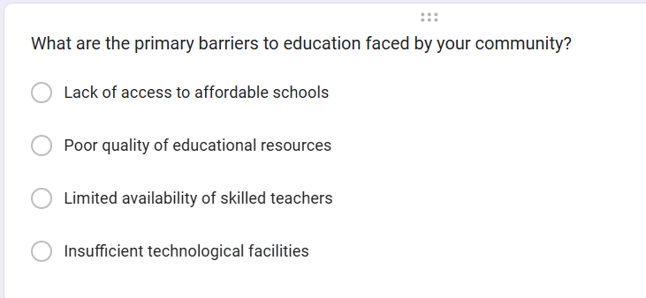
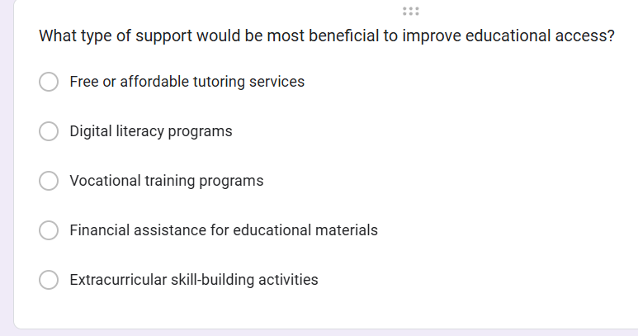
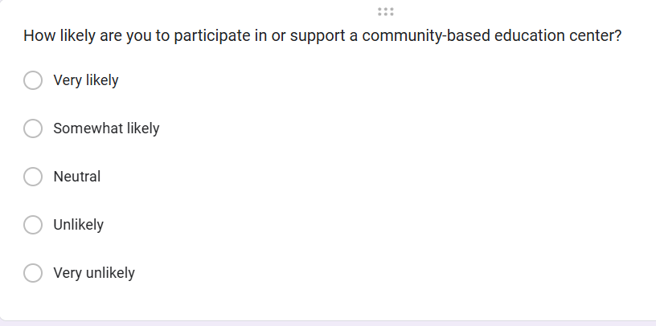

A.2 Survey Results
The data collected from the surveys revealed insightful patterns about the educational challenges faced by the community. Below are the results summarized through visual charts:

Primary Barriers to Education
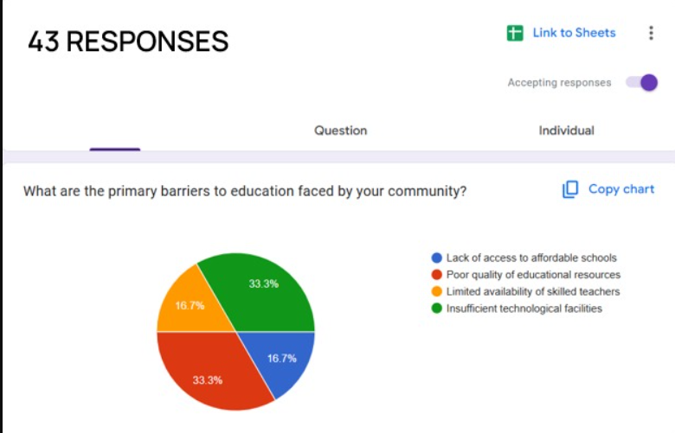

Based on the survey responses (43 total), the following barriers were identified:
- 33.3% of respondents highlighted poor quality of educational resources.
- 33.3% of respondents pointed out limited availability of skilled teachers.
- 16.7% noted lack of access to affordable schools.
- 16.7% identified insufficient technological facilities.

Figure A.2 & Figure A.3 : Support Mechanisms for Educational Access- 1&2
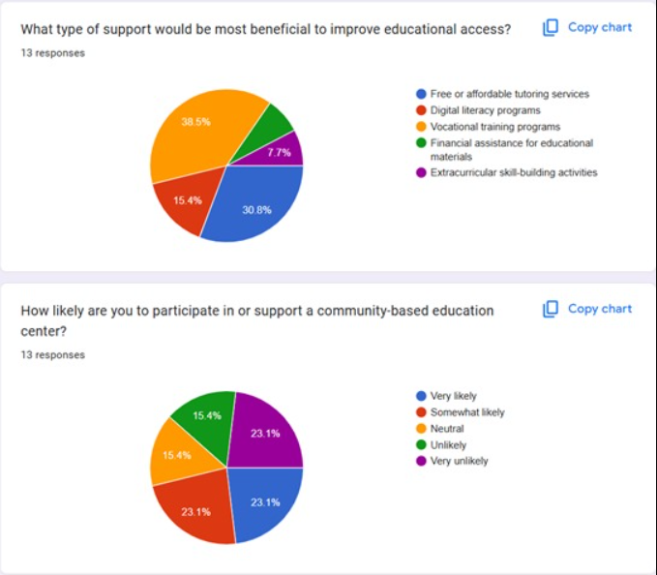

Respondents (13 total) provided the following insights about the type of support that would be most beneficial:
- 38.5% of respondents favored vocational training programs.
- 30.8% suggested free or affordable tutoring services.
- 15.4% recommended financial assistance for educational materials.
- 15.4% preferred extracurricular skill-building activities.
- 7.7% pointed to the need for digital literacy programs.

Community Participation

Regarding participation or support for a community-based education center:
- 23.1% of respondents indicated they were very likely to participate.
- 23.1% were somewhat likely.
- 23.1% were neutral.
- 15.4% were unlikely.
- 15.4% were very unlikely.

